Answers
1. State the output from each of the following six logic diagrams and express the diagram in the form of Boolean algebra. For example:
A = 0
B = 1
P = 0 Boolean algebra: P = A AND B

(a) | A = 0  P = 1 Boolean algebra: P = A NAND B  B = 1 | [2]
(b) | A = 1  B = 1  P = 0 Boolean algebra: P = A XOR B | [2]
(c) | A = 1  P = 0 Boolean algebra: P = NOT A | [2]
(d) | A = 0  P = 1 Boolean algebra: P = NOT (A AND B)  B = 1 | [2]

(e) Complete the truth table for the final logic diagram in (d) above: [2]
A | B | R = A AND B | P = NOT (A AND B)
1 | 1 | 1 | 0
1 | 0 | 0 | 1
0 | 1 | 0 | 1
0 | 0 | 0 | 1

2. Show on the diagram below the output from each of the gates, including
the output P. [2]
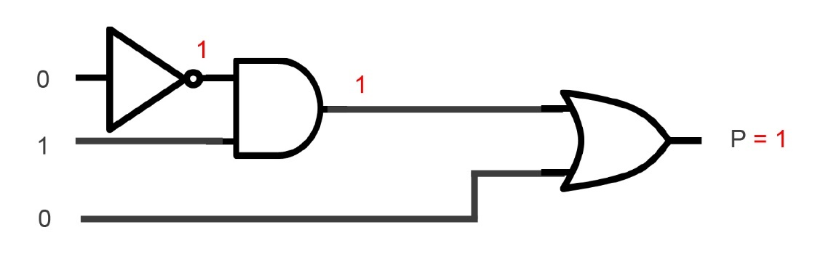
3. A car has two doors. If the ignition is on, and either of the doors is not properly closed, a warning light is displayed.
(a) Complete the truth table below. [4]
Door 1 open (D1) | Door 2 open (D2) | Ignition on (I) | Working space  D = D1 OR D2 | Warning light on (W)  I AND D
0 | 0 | 0 | 0 | 0
0 | 0 | 1 | 0 | 0
0 | 1 | 0 | 1 | 0
0 | 1 | 1 | 1 | 1
1 | 0 | 0 | 1 | 0
1 | 0 | 1 | 1 | 1
1 | 1 | 0 | 1 | 0
1 | 1 | 1 | 1 | 1

(b) Draw a logic circuit diagram for this scenario. [4]
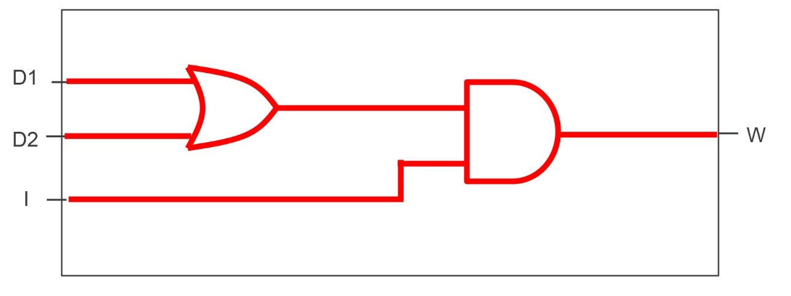
[Total marks 20]

